A PROJECT REPORT
ON
FOUNDATIONS OF ARTIFICIAL INTELLIGENCE

TEMPLE SENSE AI

A PROJECT REPORT

Submitted by
2116240701477 – SARAN KARTHICK A
2116240701472 – SANTHOSH SV


October, 2026

BONAFIDE CERTIFICATE

Certified that this project report “TEMPLE SENSE AI” is the bonafide work of “SARAN KARTHICK A” and “SANTHOSH SV” who carried out the project work under my supervision.

SIGNATURE OF THE FACULTY INCHARGE

Submitted for the Practical Examination held on _________________

SIGNATURE OF THE INTERNAL EXAMINER
TABLE OF CONTENTS
CHAPTER | TITLE | PAGE NO.
ABSTRACT |  | 5
1 | INTRODUCTION | 6
2 | LITERATURE SURVEY AND AI BACKGROUND | 8
3 | REQUIREMENT ANALYSIS | 10
4 | SYSTEM DESIGN | 12
5 | DATASET AND FEATURE ENGINEERING | 14
6 | MACHINE LEARNING MODEL | 17
7 | IMPLEMENTATION | 18
8 | TESTING AND RESULTS | 19
9 | MAPPING TO FUNDAMENTALS OF AI CONCEPTS | 24
10 | CHALLENGES AND LIMITATIONS | 25
11 | FUTURE ENHANCEMENTS | 26
12 | CONCLUSION | 27
REFERENCES |  | 28
APPENDIX: HOW TO RUN THE PROJECT |  | 29

ABSTRACT
Temples in Tamil Nadu receive heavy and highly uneven footfall: weekends, Tamil festivals, public holidays and auspicious lunar days such as Amavasai, Pournami, Pradosham and Ekadasi can multiply the number of devotees several times over, yet devotees have no dependable way of knowing how crowded a temple will be before they travel. TempleSense AI is a supervised machine-learning system that addresses this problem. Given a temple and a date, it predicts the expected crowd level as one of four classes – Low, Moderate, High or Very High – and converts the prediction into an actionable recommendation consisting of the best time window, the expected waiting time and a travel tip.
The system is built on a seeded, formula-based synthetic dataset of 34,680 daily records covering 20 temples in 12 districts from January 2022 to September 2026. Each record is described by 19 features, including day of week, weekend and holiday flags, Tamil month, approximate lunar-day indicators, festival and festival-proximity flags, weather and season. A Random Forest classifier is trained on 80% of the data and evaluated on the remaining 20%. It achieves an accuracy of 76.4% (weighted F1 76.4%) on unseen data and 76.2% ± 0.6% under five-fold cross-validation, clearly outperforming K-Nearest Neighbours (62.9%) and Logistic Regression (60.0%), and matching a single Decision Tree (76.4%) while giving more stable estimates. The model is served through a Flask API and an interactive HTML/CSS/JavaScript dashboard.
The report describes the problem, the AI techniques used, the system design, the dataset and feature engineering, the model and its evaluation, the implementation, testing, limitations and future work. Because the data is synthetic, the reported figures demonstrate the correctness of the end-to-end AI pipeline rather than real-world forecasting accuracy.
Keywords: crowd prediction, Random Forest, supervised classification, feature engineering, Tamil calendar, recommendation system, Flask.

CHAPTER 1: INTRODUCTION

1.1 Background
Tamil Nadu is home to thousands of temples, and several of them – Meenakshi Amman at Madurai, Ramanathaswamy at Rameswaram, Srirangam, Arunachaleswarar at Tiruvannamalai and Palani Murugan, to name a few – receive very large numbers of devotees every day. Footfall is far from uniform. It rises sharply on weekends, during school holidays, on public holidays and long weekends, and on days that carry religious significance in the Tamil calendar. A devotee planning a visit currently relies on word of mouth or memory of earlier visits, both of which are unreliable, and the result is long queues, long waiting times and a diminished experience of worship.
Artificial Intelligence offers a natural solution. Crowd behaviour is not random: it is driven by a recognisable set of recurring factors. A machine-learning model that has seen how these factors combined on past days can estimate the crowd on a future day. TempleSense AI applies this idea to temples, moving a temple-information website from a purely descriptive service to a predictive and recommendation-driven one.

1.2 Problem Statement
Devotees have no dependable mechanism to estimate how crowded a temple will be on a chosen date before they travel. Given a temple and a future date, the problem is to predict the crowd level (Low, Moderate, High or Very High) using calendar, festival, holiday and weather information, and to turn that prediction into practical visiting advice.

1.3 Objectives
- To formulate temple crowd forecasting as a supervised, four-class classification problem.
- To engineer culturally specific features – Tamil month, Amavasai, Pournami, Pradosham, Ekadasi and temple festivals – alongside holiday and weather features.
- To train and compare several classifiers (Random Forest, Decision Tree, K-Nearest Neighbours, Logistic Regression) and evaluate them with accuracy, precision, recall, F1-score, confusion matrix and cross-validation.
- To build a rule-based recommendation layer that converts the predicted class into the best visiting time, expected waiting time and travel tip.
- To deploy the model behind a Flask API and an interactive dashboard that non-technical devotees can use.
- To relate each part of the project to the core concepts studied in Fundamentals of Artificial Intelligence.

1.4 Scope and Limitations
The project covers dataset preparation, feature engineering, model training and evaluation, the recommendation logic, a web dashboard with temple search, district filter and date selection, and automated testing. It does not cover real-time crowd sensing with CCTV or IoT counters, live GPS tracking, ticket booking integration or a native mobile application. The dataset is synthetic and the lunar-day features are approximations; therefore the reported accuracy describes the pipeline on the prepared data and must not be read as a guarantee for real temples.

1.5 Organisation of the Report
Chapter 2 reviews the AI background. Chapter 3 lists the requirements. Chapter 4 presents the system design. Chapter 5 describes the dataset and feature engineering. Chapter 6 explains the machine-learning model. Chapter 7 covers the implementation. Chapter 8 reports testing and results. Chapter 9 maps the project to AI concepts. Chapters 10 to 12 discuss limitations, future enhancements and the conclusion.

CHAPTER 2: LITERATURE SURVEY AND AI BACKGROUND

2.1 Crowd and Footfall Forecasting
Forecasting the number of people at a place and time is a common problem in transport planning, retail, tourism and event management. Approaches fall broadly into three groups: statistical time-series models that extrapolate past counts, machine-learning models that learn a mapping from contextual features to a count or a category, and sensing-based systems that count people directly with cameras or sensors. Time-series models work well when a long, regular history of counts exists. Sensing-based systems give live information but need hardware and data-sharing arrangements with the venue. Feature-based machine learning sits between the two: it needs only historical records and calendar knowledge, which makes it suitable for an academic project and for places where no sensing infrastructure exists.

2.2 Supervised Learning and Classification
In supervised learning, a model is trained on examples for which the correct output is known and then used to predict the output for new inputs [3], [4]. When the output is one of a fixed set of categories the task is classification. Temple crowd level is an ordered categorical variable with four values, so a multi-class classifier is appropriate. Performance is judged on data the model has not seen, using a held-out test set and cross-validation, in order to estimate how well the model generalises rather than how well it memorises [5].

2.3 Decision Trees and Random Forests
A decision tree classifies an example by asking a sequence of questions about its features, for example “is it a weekend?” followed by “is it a festival?”. Trees handle mixed categorical and numerical features and are easy to interpret, but a single deep tree tends to overfit. A Random Forest builds many trees, each on a bootstrap sample of the data and a random subset of features at each split, and combines their votes [1]. Averaging many de-correlated trees reduces variance, resists overfitting, and gives feature-importance scores that explain which inputs drive the prediction. These properties make Random Forest a sound choice for the tabular, mixed-type data in this project.

2.4 Evaluation Measures
Accuracy alone can mislead when classes are imbalanced, as the Very High class is here. Precision measures how many predicted members of a class are correct, recall measures how many true members were found, and the F1-score is their harmonic mean. The confusion matrix shows which classes are confused with one another [11]. Because the crowd levels are ordered, it is also informative to check whether errors fall between neighbouring levels (for example Moderate versus High) rather than between distant ones (Low versus Very High).

2.5 Class Imbalance
Very High crowds are rarer than Low or Moderate ones. Common remedies are class weighting, resampling and synthetic oversampling such as SMOTE [10]. In this project stratified splitting guarantees that every class appears in the training and test sets in the same proportion, and the per-class precision and recall are inspected to confirm that the model does not simply favour the majority class.

2.6 Research Gap Addressed
Existing temple websites present static information – timings, history and maps – and do not forecast crowds. General crowd-forecasting work does not account for the Tamil lunar calendar, whose auspicious days do not fall on fixed Gregorian dates. TempleSense AI fills this gap by encoding Tamil-calendar and festival features explicitly and by linking the prediction to a recommendation a devotee can act on.

CHAPTER 3: REQUIREMENT ANALYSIS

3.1 Functional Requirements
- Search temples by name and filter them by district.
- Select a date for which a crowd prediction is required.
- Predict the crowd level as Low, Moderate, High or Very High and show the confidence for each class.
- Recommend the best darshan time, expected waiting time and a travel tip for the predicted level.
- Show the Tamil month, the festival (if any) and the active factors such as weekend, holiday, Amavasai or Pournami.
- Show a seven-day outlook and suggest the lightest day.
- Provide temple details and a Google Maps link.
- Reject unknown temples and invalid dates with a clear error message.

3.2 Non-Functional Requirements
- Accuracy: the classifier should generalise well to unseen records, judged on a held-out test set and cross-validation.
- Reliability: every supported temple and date should return a valid prediction.
- Performance: a prediction should return almost instantly because the model is loaded once at start-up.
- Maintainability: data generation, feature engineering, training and serving are kept in separate modules that share one feature routine.
- Scalability: new temples, festivals or features can be added by editing the temple list and feature module.
- Usability: results are presented in plain language with colour-coded crowd levels.

3.3 Hardware and Software Requirements
Table 3.1: Hardware and software requirements
Category | Requirement
Hardware | Laptop or desktop, minimum 8 GB RAM, internet connection (for installing packages and map links)
Operating system | Windows, macOS or Linux
Language | Python 3.10 or later; HTML, CSS and JavaScript
ML libraries | scikit-learn, pandas, NumPy, joblib
Visualisation | Matplotlib
Web framework | Flask
Tools and data | Visual Studio Code, Git and GitHub; CSV data files

CHAPTER 4: SYSTEM DESIGN

4.1 System Architecture
TempleSense AI follows a layered pipeline. The devotee selects a temple and a date. The backend converts them into a feature vector, the trained Random Forest predicts the crowd level, the recommendation logic turns the prediction into advice, and the Flask API returns the result as JSON to the dashboard. Training is an offline activity: the dataset is cleaned and encoded, split into training and test sets, and used to fit the model, which is saved to disk and loaded once when the web application starts.
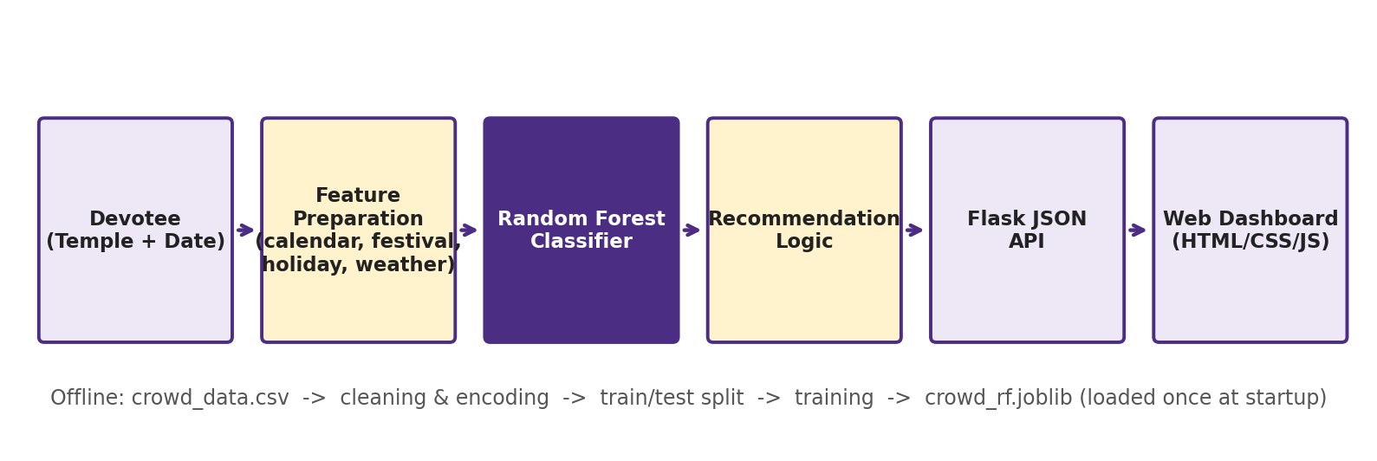
Figure 4.1: Overall architecture of TempleSense AI

4.2 Intelligent Agent View (PEAS)
The system can be described as a goal-based, utility-oriented software agent in the sense of Russell and Norvig [3]. Its PEAS description is given in Table 4.1.
Table 4.1: PEAS description of the TempleSense AI agent
Element | Description
Performance measure | Classification accuracy, F1-score, usefulness of the recommendation (shorter waiting for the devotee)
Environment | Temples, calendar (Tamil month, lunar days, festivals), public and school holidays, weather
Actuators | Dashboard output: crowd level, best time, waiting time, travel tip, seven-day outlook
Sensors | User input (temple and date) and stored datasets (CSV files)

4.3 Use Cases
The primary actor is the devotee, who can search for a temple, filter by district, choose a date, view the crowd prediction, view the best darshan time recommendation, view temple information and view the festival and calendar context of the selected date. The secondary actor is the system, which invokes the model and assembles the recommendation after each query.

4.4 Data Flow
At Level 0 the system is a single process that accepts a temple name and a date and returns a prediction, a recommendation and temple information, with the datasets as the underlying store. At Level 1 the process splits into five stages: (i) input handling, which validates the temple and date; (ii) feature assembly, which derives day of week, weekend flag, Tamil month, lunar-day flags, festival flags, holiday flags and expected weather; (iii) model inference, which passes the feature vector to the Random Forest; (iv) recommendation generation, which maps the class to a time window, waiting time and tip; and (v) response assembly, which packages everything as JSON for the dashboard.

4.5 System Modules
Table 4.2: Modules of TempleSense AI
Module | Responsibility
Crowd Prediction | Builds the feature vector and obtains the class and class probabilities from the Random Forest
Recommendation | Maps Low / Moderate / High / Very High to time window, waiting time and travel tip
Tamil Calendar | Derives Tamil month, tithi-based flags (Amavasai, Pournami, Ekadasi, Pradosham) and festivals
Holiday Analysis | Flags public holidays, school holidays and long weekends
Weather Analysis | Supplies season and expected weather, temperature and rainfall
Temple Information | Provides district, deity, special festivals and a Google Maps link
Dashboard | Search, filter, date selection, probability bars and seven-day outlook

4.6 Project Structure
TempleSense_AI/
features.py shared feature engineering (calendar, festival,
holiday, weather)
generate_data.py builds the four CSV datasets
train_model.py trains, compares and evaluates models; saves model
and charts
app.py Flask API and page routes
templates/ dashboard page (HTML)
static/ dashboard styles and scripts (CSS, JavaScript)
tests.py 16 unit and API tests
data/ datasets
model/ saved model and metrics
docs/ figures

CHAPTER 5: DATASET AND FEATURE ENGINEERING

5.1 Datasets
Four CSV files are produced by generate_data.py: temples.csv (20 temples with district, deity type and popularity), festival_calendar.csv (festival dates), holidays.csv (public and school holidays) and crowd_data.csv, the main training file. crowd_data.csv contains 34,680 rows – one per temple per day – from 1 January 2022 to 30 September 2026. The 20 temples lie in 12 districts and include Meenakshi Amman (Madurai), Brihadeeswarar (Thanjavur), Ramanathaswamy (Ramanathapuram), Srirangam Ranganathaswamy (Tiruchirappalli), Arunachaleswarar (Tiruvannamalai), Kapaleeshwarar (Chennai), Palani Murugan (Dindigul) and Thiruchendur Murugan (Thoothukudi).
Real daily footfall records are not publicly available for these temples, so the data is synthetic. A fixed random seed makes it fully reproducible. For each temple and day, a crowd ratio is computed as the product of the temple’s base popularity and multipliers for weekends, public holidays, long weekends, school holidays, festivals (with an additional boost at temples for which the festival is special), festival proximity, Pournami, Amavasai, Pradosham and Ekadasi (for the relevant deity types), rain and high temperature, with log-normal random noise to represent real-world variation. The ratio is converted into one of four crowd levels, and a waiting time in minutes is drawn from a range that depends on the level.

5.2 Fields of the Main Dataset
Table 5.1: Principal fields of crowd_data.csv
Field | Description
date, temple, district | Day, temple name and its district
day_of_week, weekend, month | Weekday number (0 = Monday), weekend flag, calendar month
tamil_month, season | Tamil month (Chithirai … Panguni) and broad season
festival, festival_proximity | Festival on the date (or None); flag for dates within two days of a festival
is_amavasai, is_pournami, is_ekadasi, is_pradosham | Lunar-day indicators derived from the moon phase
public_holiday, school_holiday, long_weekend | Holiday context flags
weather, temperature, rainfall_mm | Weather category, temperature (°C) and rainfall
crowd_level (target) | Low, Moderate, High or Very High
waiting_time_min | Waiting time in minutes (used by the recommendation layer)

5.3 Tamil Calendar and Festival Encoding
Tamil festivals do not fall on fixed Gregorian dates, so they are derived. The Tamil month is determined from the approximate dates on which the sun enters each zodiac sign (for example Chithirai begins around 14 April). The lunar day (tithi) is computed from the age of the moon, using a reference new moon and the mean synodic month of 29.53 days, which divides each lunar month into 30 tithis. Tithi 30 is taken as Amavasai, tithi 15 as Pournami, tithis 11 and 26 as Ekadasi and tithis 13 and 28 as Pradosham. Named festivals are then derived by combining month and tithi – for example Pournami in Chithirai is Chitra Pournami, Pournami in Thai is Thai Poosam, Pournami in Panguni is Panguni Uthiram, Pournami in Karthigai is Karthigai Deepam, and Ekadasi in Margazhi is Vaikunta Ekadasi. Pongal, Tamil New Year, Aadi Perukku, Deepavali and Vinayagar Chathurthi are added from fixed or tabulated dates.
The unit tests verify this logic against known dates: Thai Poosam on 25 January 2024, Chitra Pournami on 23 April 2024, Maha Shivaratri on 8 March 2024 and Vaikunta Ekadasi on 30 December 2025 are all identified correctly. Because the method is an astronomical approximation and not a full Panchangam, results can differ from the published almanac by a day in some years, which is acknowledged as a limitation.

5.4 Feature Engineering
Table 5.2: Features supplied to the model (19 in total)
Type | Features
Calendar | day_of_week, weekend, month, tamil_month, season
Lunar and festival | is_amavasai, is_pournami, is_ekadasi, is_pradosham, festival, festival_proximity
Holiday | public_holiday, school_holiday, long_weekend
Weather | weather, temperature, rainfall_mm
Location | temple, district

Categorical fields (temple, district, Tamil month, festival, weather, season) are label-encoded with fixed category lists defined in one module, so exactly the same encoding is used during training and prediction. Duplicate checking and range checks on temperature and rainfall are applied; because the data is generated, it contains no missing values, but the encoder rejects unknown categories rather than silently mapping them. The weather features are grouped into three categories (Sunny, Cloudy, Rainy) to reduce sparsity, and a composite long-weekend flag captures a holiday adjacent to a weekend.

5.5 Class Distribution
The target classes are imbalanced: Low 40.2%, Moderate 29.5%, High 21.8% and Very High 8.5% of all records (Figure 5.1). This resembles real life, where extreme crowds are rare, and is the reason why stratified splitting and per-class metrics are used.
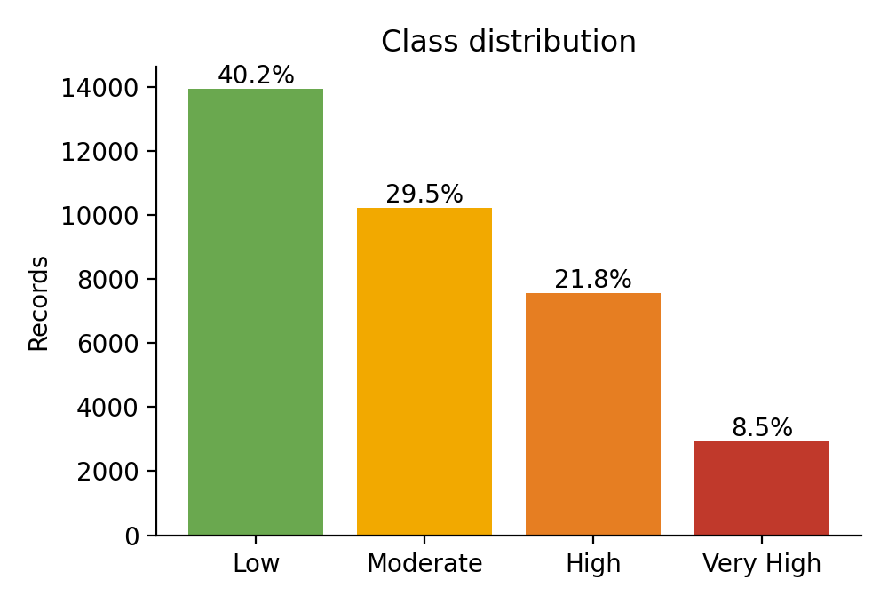
Figure 5.1: Distribution of crowd levels in the dataset
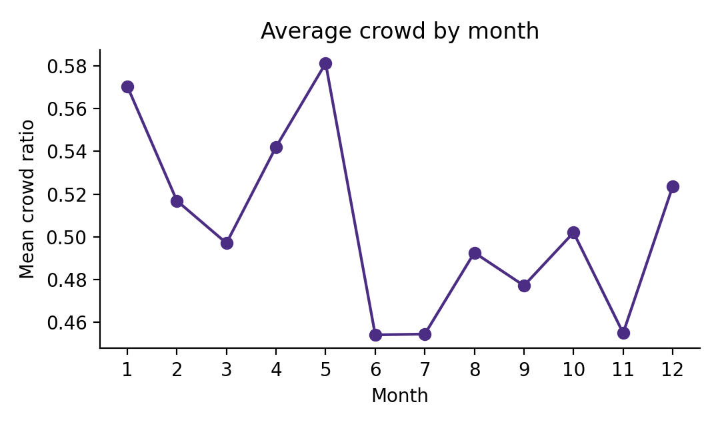
Figure 5.2: Average crowd ratio by month across all temples

CHAPTER 6: MACHINE LEARNING MODEL

6.1 Model Selection
A Random Forest classifier was chosen as the main model because the feature set mixes categorical and numerical variables, because it needs little tuning, because its ensemble of trees resists overfitting on a dataset of moderate size, and because it provides feature importances that explain predictions. To justify the choice, three other classifiers were trained on the same split: a single Decision Tree, K-Nearest Neighbours (k = 7, on standardised features) and Logistic Regression (on standardised features).

6.2 Workflow
Data collection and generation → cleaning and validation → feature engineering → label encoding → stratified 80/20 train–test split → model training → prediction → evaluation. The split is stratified so that all four classes appear in both sets in the same proportion. The training set contains 27,744 records and the test set 6,936 records. The random seed is fixed at 42 for reproducibility.

6.3 Training Configuration
Table 6.1: Random Forest configuration
Parameter | Value
n_estimators | 200 trees
min_samples_leaf | 3 (prevents leaves that fit single noisy records)
max_features | 0.7 (each split considers 70% of the features)
max_depth | None (limited by min_samples_leaf)
random_state | 42

Several settings were tried on the training data before this configuration was chosen. Very deep, fully grown trees with a leaf size of one fitted the noise in the data and gave a slightly lower test accuracy, whereas a leaf size of three with 70% feature sampling gave the best result. The final model is saved with joblib so that the web application loads it once instead of retraining.

CHAPTER 7: IMPLEMENTATION

7.1 Backend
The backend is written in Python with Flask. The route /api/predict accepts the temple name and a date in YYYY-MM-DD format. After validating them, it calls the shared feature routine to derive the calendar, festival, holiday and expected-weather features, encodes them, and passes the vector to the Random Forest, which returns class probabilities. The class with the highest probability is the prediction. The same call is repeated for the next six days to produce a seven-day outlook, and the day with the lowest predicted level is reported as the best day. The route /api/temples supports searching by name and filtering by district. Invalid temples or dates return an HTTP 400 error with a message.

7.2 Recommendation Logic
Table 7.1: Mapping from predicted crowd level to advice
Level | Best time | Expected waiting | Advice
Low | 10 AM – 12 PM or 5 – 7 PM | 10 – 20 min | Calm day, ideal for darshan
Moderate | 6 – 8 AM or after 6:30 PM | 30 – 45 min | Avoid the late-morning rush
High | Before 6 AM or after 8 PM | 60 – 90 min | Expect queues, plan extra time
Very High | Before 5 AM or another date | 2 – 3 hours | Peak crowd, consider the lighter day

This layer is knowledge-based: it encodes simple expert rules on top of the learned prediction, so that the output of the classifier becomes a decision the devotee can act on.

7.3 Frontend
The dashboard is a single page built with HTML, CSS and JavaScript. A control panel provides a search box, a district drop-down, a temple drop-down and a date picker. When the user presses the Predict button, JavaScript sends an asynchronous request to the API, shows a loading message, and updates the page without reloading it. The result area shows a colour-coded crowd badge, the Tamil month, festival and active factors, three recommendation cards, probability bars for the four classes, a seven-day strip coloured by predicted level, and a link to Google Maps.

CHAPTER 8: TESTING AND RESULTS

8.1 Testing Strategy
Testing was performed at two levels. The machine-learning pipeline was evaluated on a held-out test set and with five-fold cross-validation. The calendar logic, the model wrapper and the web API were verified with 16 automated tests written with Python’s unittest module (tests.py); all 16 passed.
Table 8.1: Automated test cases
Group | Test | Result
Calendar | Thai Poosam identified on 25 Jan 2024 | Passed
Calendar | Chitra Pournami identified on 23 Apr 2024 | Passed
Calendar | Maha Shivaratri identified on 8 Mar 2024 | Passed
Calendar | Vaikunta Ekadasi identified on 30 Dec 2025 | Passed
Calendar | Tamil New Year recognised as a public holiday | Passed
Calendar | Saturday flagged as weekend | Passed
Calendar | Tamil month Thai for 20 Jan 2026 | Passed
Calendar | Amavasai and Pournami flags on known dates | Passed
Model | Valid crowd level returned for all 20 temples | Passed
Model | Class probabilities sum to 1 | Passed
Model | Festival day not predicted lower than an ordinary day | Passed
API | Home page loads (HTTP 200) | Passed
API | District filter returns only matching temples | Passed
API | Valid prediction with 7-day outlook | Passed
API | Unknown temple rejected (HTTP 400) | Passed
API | Invalid date rejected (HTTP 400) | Passed

8.2 Model Performance
Table 8.2: Test-set performance of the four classifiers (weighted averages, %)
Model | Accuracy | Precision | Recall | F1-score
Random Forest | 76.4 | 76.4 | 76.4 | 76.4
Decision Tree | 76.4 | 76.4 | 76.4 | 76.3
KNN (k = 7) | 62.9 | 62.1 | 62.9 | 62.3
Logistic Regression | 60.0 | 59.1 | 60.0 | 59.1

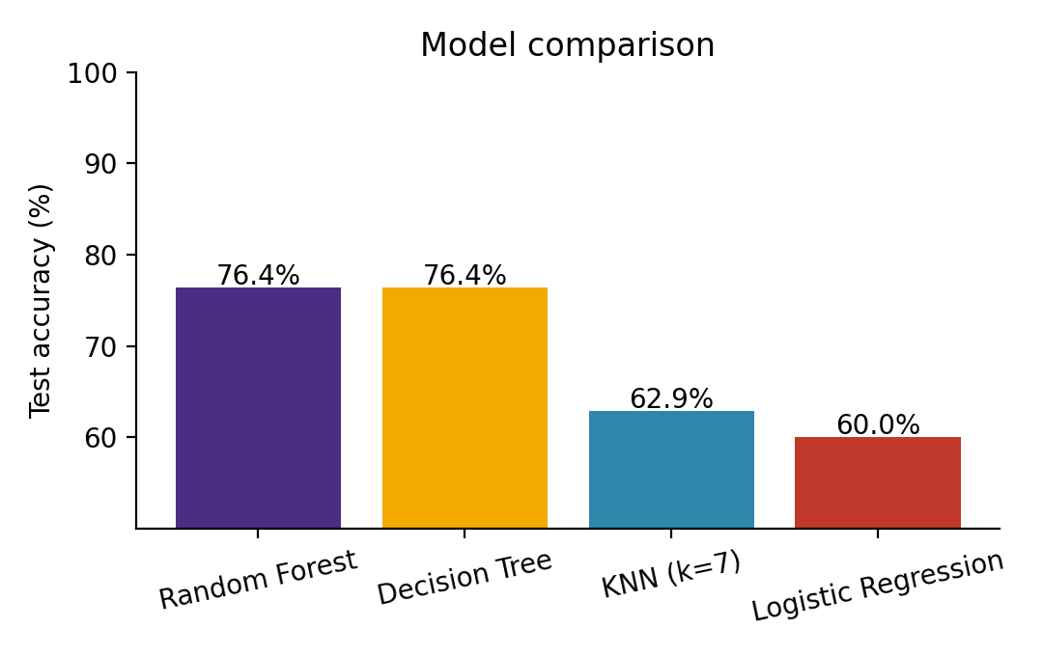
Figure 8.1: Test accuracy of the four classifiers
The Random Forest reached 76.4% accuracy on the 6,936 unseen records. Five-fold stratified cross-validation gave 76.2% with a standard deviation of only 0.6 percentage points, showing that the result does not depend on one lucky split. The Random Forest and the Decision Tree are almost equal on the test set (76.4% versus 76.4%), which is expected because the data was generated from rules that a tree can recover; the forest is preferred because it is more stable and gives smoother class probabilities for the confidence bars. Both tree-based models are about fourteen to sixteen percentage points better than KNN and Logistic Regression, because the relationship between the features and the crowd is multiplicative and conditional (for example, a festival matters more at a temple for which it is special) and cannot be expressed by a linear boundary.

8.3 Per-Class Results
Table 8.3: Precision, recall and F1-score per class (Random Forest, %)
Class | Precision | Recall | F1-score | Support
Low | 84.6 | 87.2 | 85.9 | 2790
Moderate | 66.3 | 66.0 | 66.1 | 2046
High | 72.1 | 71.1 | 71.6 | 1513
Very High | 83.1 | 75.3 | 79.0 | 587

Table 8.4: Confusion matrix on the test set (rows: actual, columns: predicted)
Actual \ Predicted | Low | Moderate | High | Very High
Low | 2434 | 352 | 4 | 0
Moderate | 427 | 1350 | 269 | 0
High | 15 | 332 | 1076 | 90
Very High | 0 | 2 | 143 | 442

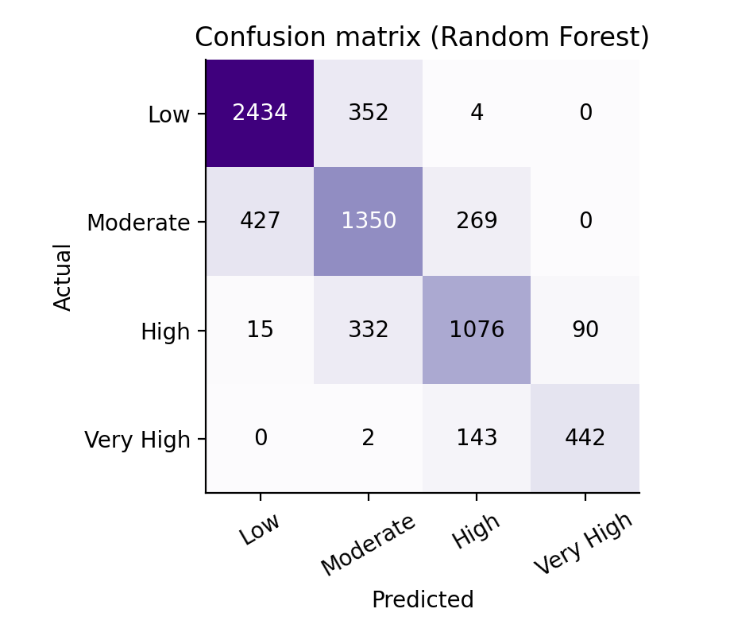
Figure 8.2: Confusion matrix of the Random Forest
The extreme classes are recognised best: Low has an F1-score of 85.9% and Very High 79.0%. The Moderate class is the hardest (F1 66.1%) because it lies between two neighbours. Importantly, errors are almost entirely between neighbouring levels: only 21 of 6,936 test records (0.3%) are placed two or more levels away from the true class, and no Very High record was predicted as Low. For a visitor, mistaking Moderate for High is a mild error, whereas mistaking Very High for Low would be a serious one, and the model avoids the latter.

8.4 Feature Importance
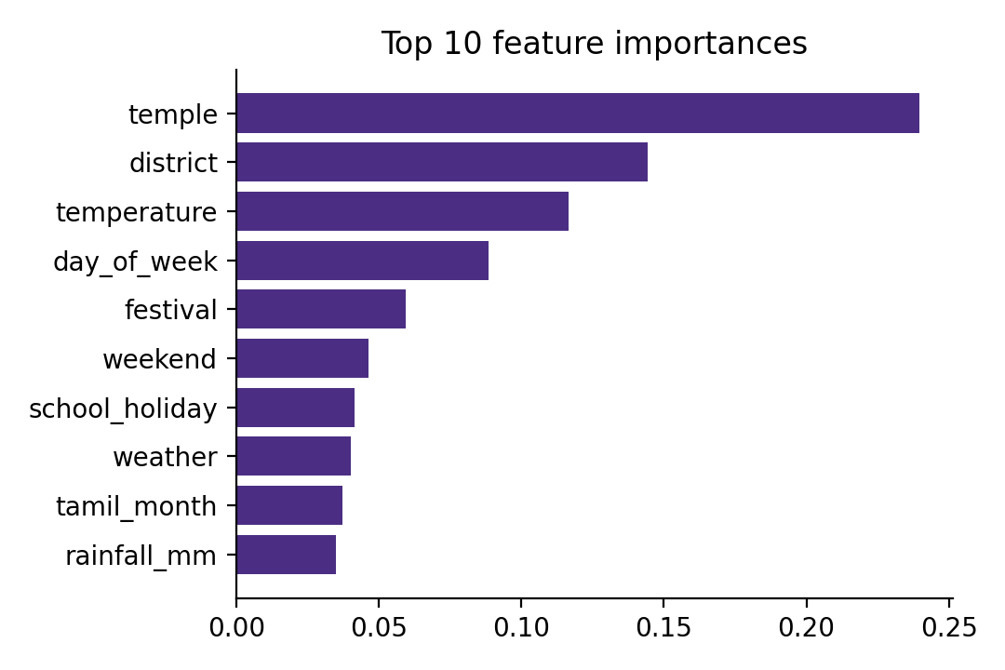
Figure 8.3: Ten most important features of the Random Forest
The five most influential features are temple (24.0%), district (14.4%), temperature (11.7%), day of week (8.8%), festival (6.0%). The temple and district features rank highest because the temples differ in popularity, and temperature ranks high partly because it varies with the season and so carries information about the time of year. Weekend and day-of-week, festival and holiday features follow, in line with the way the data was generated and with intuition about real temple visits. Impurity-based importances are known to favour features with many distinct values, so these scores should be read as a guide to the model’s behaviour and not as a causal ranking.

8.5 Discussion
The results show that the full AI pipeline works: culturally specific features were engineered, several models were compared fairly, and the best model was integrated into a usable application. The accuracy of about 76% is not a limitation of the algorithm so much as a property of the data: the generator adds random noise to every record, and records whose true ratio lies close to a class boundary cannot be classified perfectly by any model. Because the data is synthetic, the absolute numbers say nothing about real temples; with real footfall records the same code could be retrained and its accuracy re-measured.
8.6 APPLICATION OUTPUT SCREENSHOTS
The following figures document the implemented dashboard: temple and date selection, the prediction result with darshan recommendations, and the seven-day crowd forecast. These are example outputs of the project's model and should not be interpreted as guarantees of actual crowd conditions.
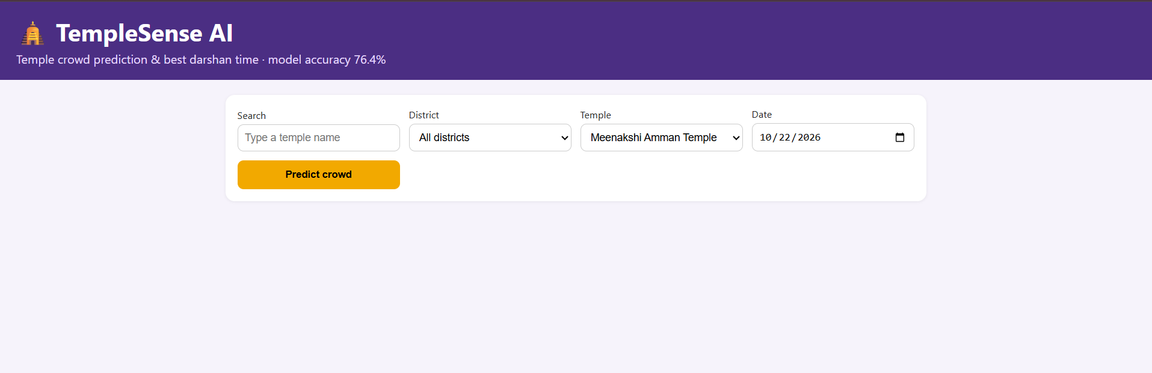
Figure 8.6.1: Temple and date selection interface
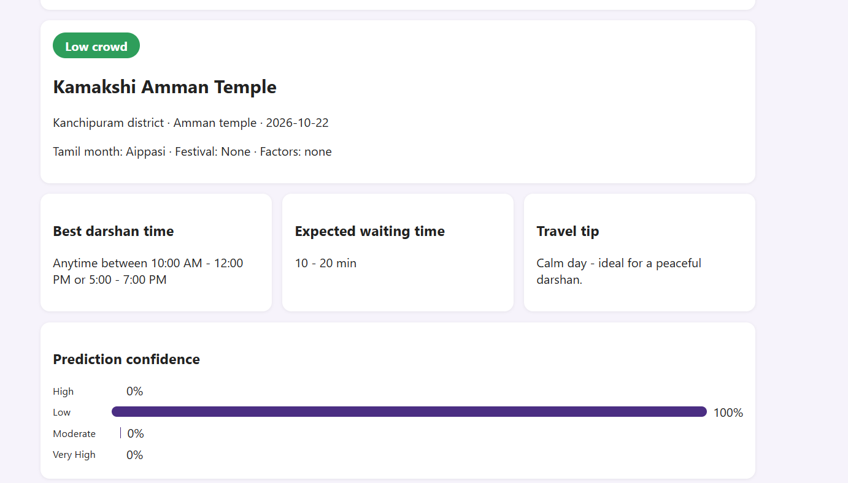
Figure 8.6.2: Crowd prediction and darshan recommendations
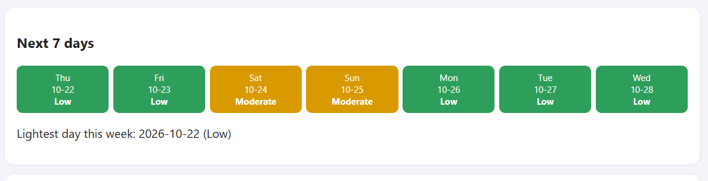
Figure 8.6.3: Seven-day crowd forecast

CHAPTER 9: MAPPING TO FUNDAMENTALS OF AI CONCEPTS
Table 9.1: AI concepts demonstrated in the project
AI concept | Where it appears in TempleSense AI
Intelligent agent and PEAS | The system perceives temple and date, acts by producing a recommendation (Section 4.2)
Machine learning – supervised learning | Four-class classification trained on labelled historical records
Knowledge representation | Tamil calendar, festivals and holidays represented as features and rules
Feature engineering | Lunar-day flags, festival proximity, long-weekend composite and weather grouping
Search and optimisation (light) | Selecting the lightest day of the next seven by scanning predicted levels
Uncertainty and probability | Class probabilities from the forest shown as confidence bars
Ensemble methods | Random Forest combining 200 decision trees by voting
Model evaluation | Train–test split, cross-validation, precision, recall, F1-score, confusion matrix
Overfitting and generalisation | Leaf-size constraint, held-out test data and cross-validation
Knowledge-based systems | Rule table mapping each crowd level to time, waiting time and advice
Ethics and limitations | Synthetic data disclosed; predictions are estimates, not guarantees

CHAPTER 10: CHALLENGES AND LIMITATIONS
- Encoding Tamil calendar events that move each year, solved by deriving lunar days from the moon’s phase and combining them with the Tamil month; this remains an approximation that can differ from the Panchangam by a day.
- Absence of real, public footfall data for temples, which led to a synthetic and seeded dataset; the reported accuracy therefore reflects the pipeline and not real-world performance.
- Class imbalance, since Very High crowds are rare; handled with stratified splitting and per-class evaluation.
- Avoiding double counting when several factors coincide, for example a festival on a public-holiday weekend; handled by multiplicative combination in the generator and by letting the forest learn interactions.
- Keeping the encoding identical between training and serving, solved by a single shared feature module.
- Weather for a future date is unknown, so the application uses expected weather for the month instead of a real forecast.
- Temple timings and the recommendation windows are typical values and should be confirmed with the temple.

CHAPTER 11: FUTURE ENHANCEMENTS
- Train on real footfall data obtained from temple administrations, with re-evaluation of the accuracy.
- Integrate a live weather forecast API and an official government holiday API.
- Add real-time crowd sensing with CCTV-based counters or IoT sensors and combine it with the prediction.
- Use time-series or deep-learning models such as LSTM to capture long seasonal patterns.
- Provide Tamil-language support and a mobile application with notifications.
- Extend coverage to more temples and states and add a district-level crowd heat map.
- Integrate e-darshan and ticket booking so that a favourable prediction can lead directly to a booking.
- Deploy to a cloud platform for public access.

CHAPTER 12: CONCLUSION
TempleSense AI demonstrates how core techniques of Artificial Intelligence – supervised classification, ensemble learning, feature engineering, probabilistic output and a knowledge-based recommendation layer – can be combined to solve a practical problem faced by temple visitors in Tamil Nadu. The Random Forest classifier achieved 76.4% accuracy and a weighted F1-score of 76.4% on unseen data, outperformed KNN and Logistic Regression by a wide margin, and made its errors almost exclusively between neighbouring crowd levels. The model is served through a Flask API and an interactive dashboard that translate a prediction into a best time to visit, an expected waiting time and a travel tip.
The project also shows the importance of disciplined engineering in AI work: a shared feature module, reproducible data generation, held-out evaluation, automated tests and honest disclosure of the limits of synthetic data. With real footfall data and live weather and holiday feeds, the same architecture can be retrained to give devotees a dependable basis for planning a more comfortable and predictable temple visit.

REFERENCES
[1] L. Breiman, “Random Forests,” Machine Learning, vol. 45, no. 1, pp. 5–32, 2001.
[2] F. Pedregosa et al., “Scikit-learn: Machine Learning in Python,” Journal of Machine Learning Research, vol. 12, pp. 2825–2830, 2011.
[3] S. Russell and P. Norvig, Artificial Intelligence: A Modern Approach, 4th ed. Pearson, 2021.
[4] T. M. Mitchell, Machine Learning. McGraw-Hill, 1997.
[5] T. Hastie, R. Tibshirani and J. Friedman, The Elements of Statistical Learning, 2nd ed. Springer, 2009.
[6] W. McKinney, “Data Structures for Statistical Computing in Python,” in Proc. 9th Python in Science Conference, 2010, pp. 56–61.
[7] C. R. Harris et al., “Array programming with NumPy,” Nature, vol. 585, pp. 357–362, 2020.
[8] J. D. Hunter, “Matplotlib: A 2D Graphics Environment,” Computing in Science & Engineering, vol. 9, no. 3, pp. 90–95, 2007.
[9] Flask Documentation. [Online]. Available: https://flask.palletsprojects.com
[10] N. V. Chawla, K. W. Bowyer, L. O. Hall and W. P. Kegelmeyer, “SMOTE: Synthetic Minority Over-sampling Technique,” Journal of Artificial Intelligence Research, vol. 16, pp. 321–357, 2002.
[11] M. Sokolova and G. Lapalme, “A systematic analysis of performance measures for classification tasks,” Information Processing & Management, vol. 45, no. 4, pp. 427–437, 2009.

APPENDIX: HOW TO RUN THE PROJECT
pip install -r requirements.txt
python generate_data.py # creates data/*.csv
python train_model.py # trains models, saves model and figures
python app.py # open http://127.0.0.1:5000
python -m unittest tests -v # runs the 16 tests
Sample API request and response (abridged):
GET /api/predict?temple=Palani Murugan Temple&date=2027-01-26

{
"level": "Very High",
"best_time": "Reach before 5:00 AM, or choose another date",
"waiting_time": "2 - 3 hours",
"probabilities": { "Low": ..., "Moderate": ..., "High": ...,
"Very High": ... },
"week": [ {"date": "2027-01-26", "level": "Very High"}, ... ],
"best_day": {...}
}

